**EXPERIMENT NO:1**

**Aim:**

Verification and interpretation of truth tables for AND Gates.

**Apparatus:**

Bread board, logic gates / IC - 7408 , wires ,LED

**Theory:**

Logic gates are electronic circuits which perform logical functions on one or more inputs to produce one output. There are seven logic gates. When all the input combinations of a logic gate are written in a series and their corresponding outputs written along them, then this input/ output combination is called Truth Table. Various gates and their working is explained here.

**AND Gate**

AND gate produces an output as 1, when all its inputs are 1; otherwise the output is 0. This gate can have minimum 2 inputs but output is always one. Its output is 0 when any input is 0.

**Logic diagram :**

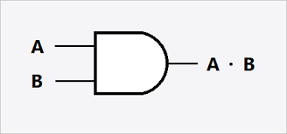

**Pin diagram and truth table :**

[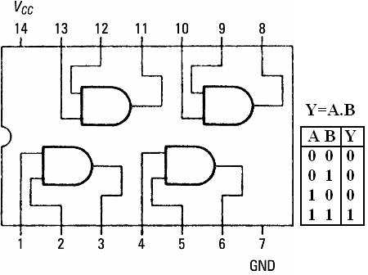](https://sites.google.com/site/amtmttl/st2/IC7408.PNG?attredirects=0)

IC 7408

**Procedure:**

1. Connect the given IC to the breadboard
2. Connect the inputs of any one logic gate to the logic sources and its output to the 1.5 v LED.
3. Connect the 9v battery with positive terminal to ‘+1’ and negative terminal to ‘0’
4. Apply various input combinations and observe output for each one.
5. Verify the truth table for each input/ output combination.
6. Remove the battery and disconnect the wires and IC from the breadboard.

**Result :**

The interpretation of truth table for -------------- Gate was successfully verified.

**EXPERIMENT NO:2**

**Aim:**

Verification and interpretation of truth tables for OR gate.

**Apparatus:**

Bread board, logic gates / IC - 7432 , wires,LED

**Theory:**

Logic gates are electronic circuits which perform logical functions on one or more inputs to produce one output. There are seven logic gates. When all the input combinations of a logic gate are written in a series and their corresponding outputs written along them, then this input/ output combination is called Truth Table. Various gates and their working is explained here.

**OR Gate**

OR gate produces an output as 1, when any or all its inputs are 1; otherwise the output is 0. This gate can have minimum 2 inputs but output is always one. Its output is 0 when all input are 0.

**Logic diagram :**



**Pin diagram and truth table :**

[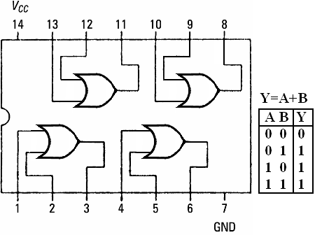](https://sites.google.com/site/amtmttl/st2/IC7432.PNG?attredirects=0)

IC 7432

**Procedure:**

1. Connect the given IC to the breadboard
2. Connect the inputs of any one logic gate to the logic sources and its output to the 1.5 v LED.
3. Connect the 9v battery with positive terminal to ‘+1’ and negative terminal to ‘0’
4. Apply various input combinations and observe output for each one.
5. Verify the truth table for each input/ output combination.
6. Remove the battery and disconnect the wires and IC from the breadboard.

**Result :**

The interpretation of truth table for -------------- Gate was successfully verified.

**EXPERIMENT NO:3**

**Aim:**

Verification and interpretation of truth tables for NOT Gates.

**Apparatus:**

Bread board, logic gates / IC - 7404 , wires,LED

**Theory:**

Logic gates are electronic circuits which perform logical functions on one or more inputs to produce one output. There are seven logic gates. When all the input combinations of a logic gate are written in a series and their corresponding outputs written along them, then this input/ output combination is called Truth Table. Various gates and their working is explained here.

**NOT Gate**

NOT gate produces the complement of its input. This gate is also called an INVERTER. It always has one input and one output. Its output is 0 when input is 1 and output is 1 when input is 0.

**Logic diagram :**

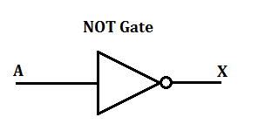

**Pin diagram and truth table :**

[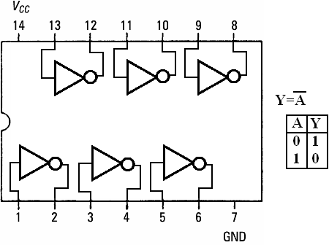](https://sites.google.com/site/amtmttl/st2/IC7404.PNG?attredirects=0)

IC 7404

**Procedure:**

1. Connect the breadboard to ac power supply.
2. Connect the inputs of any one logic gate to the logic sources and its output to the logic indicator.
3. Apply various input combinations and observe output for each one.
4. Verify the truth table for each input/ output combination.
5. Repeat the process for all other logic gates.
6. Switch off the ac power supply.

**Result :**

The interpretation of truth table for -------------- Gate was successfully verified.

**EXPERIMENT NO:4**

**Aim:**

Verification and interpretation of truth tables for NAND Gates.

**Apparatus:**

Bread board, logic gates / IC - 7400 , wires,LED

**Theory:**

Logic gates are electronic circuits which perform logical functions on one or more inputs to produce one output. There are seven logic gates. When all the input combinations of a logic gate are written in a series and their corresponding outputs written along them, then this input/ output combination is called Truth Table. Various gates and their working is explained here.

**NAND Gate**

NAND gate is actually a series of AND gate with NOT gate. If we connect the output of an AND gate to the input of a NOT gate, this combination will work as NOT-AND or NAND gate. Its output is 1 when any or all inputs are 0, otherwise output is 1.

**Logic diagram :**

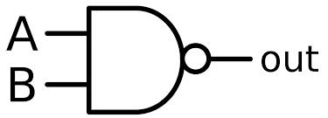

**Pin diagram and truth table :**

[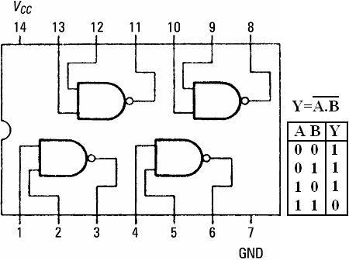](https://sites.google.com/site/amtmttl/st2/IC7400.png?attredirects=0)

IC 7400

**Procedure:**

1. Connect the breadboard to ac power supply.
2. Connect the inputs of any one logic gate to the logic sources and its output to the logic indicator.
3. Apply varous input combinations and observe output for each one.
4. Verify the truth table for each input/ output combination.
5. Repeat the process for all other logic gates.
6. Switch off the ac power supply.

**Result :**

The interpretation of truth table for -------------- Gate was successfully verified.

**EXPERIMENT NO:5**

**Aim:**

Verification and interpretation of truth tables for NOR Gates.

**Apparatus:**

Bread board, logic gates / IC - 7402 , wires,LED

**Theory:**

Logic gates are electronic circuits which perform logical functions on one or more inputs to produce one output. There are seven logic gates. When all the input combinations of a logic gate are written in a series and their corresponding outputs written along them, then this input/ output combination is called Truth Table. Various gates and their working is explained here.

**NOR Gate**

NOR gate is actually a series of OR gate with NOT gate. If we connect the output of an OR gate to the input of  a NOT gate, this combination will work as NOT-OR or NOR gate. Its output is 0 when any or all inputs are 1, otherwise output is 1.

**Logic diagram :**

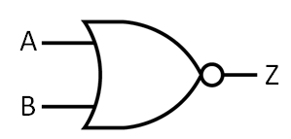

**Pin diagram and truth table :**

[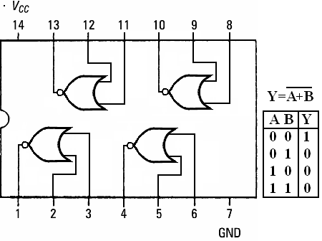](https://sites.google.com/site/amtmttl/st2/IC7402.PNG?attredirects=0)

IC 7402

**Procedure:**

1. Connect the breadboard to ac power supply.
2. Connect the inputs of any one logic gate to the logic sources and its output to the logic indicator.
3. Apply varous input combinations and observe output for each one.
4. Verify the truth table for each input/ output combination.
5. Repeat the process for all other logic gates.
6. Switch off the ac power supply.

Result :

The interpretation of truth table for -------------- Gate was successfully verified.

**EXPERIMENT NO:6**

**Aim:**

Verification and interpretation of truth tables for X-OR Gates.

**Apparatus:**

Bread board, logic gates / IC - 7486 , wires,LED

**Theory:**

Logic gates are electronic circuits which perform logical functions on one or more inputs to produce one output. There are seven logic gates. When all the input combinations of a logic gate are written in a series and their corresponding outputs written along them, then this input/ output combination is called Truth Table. Various gates and their working is explained here.

**Exclusive OR (X-OR) Gate**

X-OR gate produces an output as 1, when number of 1’s at its inputs is odd, otherwise output is 0. It has two inputs and one output.

**Logic diagram :**

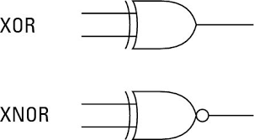

**Pin diagram and truth table :**

[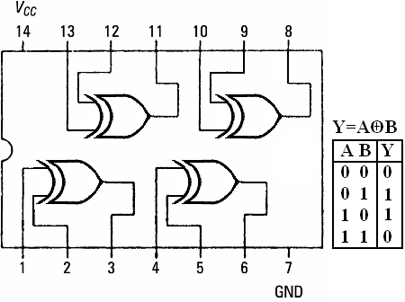](https://sites.google.com/site/amtmttl/st2/IC7486.PNG?attredirects=0)

IC 7486

**Procedure:**

1. Connect the breadboard to ac power supply.
2. Connect the inputs of any one logic gate to the logic sources and its output to the logic indicator.
3. Apply varous input combinations and observe output for each one.
4. Verify the truth table for each input/ output combination.
5. Repeat the process for all other logic gates.
6. Switch off the ac power supply.

Result :

The interpretation of truth table for -------------- Gate was successfully verified.

**EXPERIMENT NO : 7**

**Aim:**

To measure the voltage, current and continuity using Digital multimeter.

**Apparatus:**

Digital multimeter with probes,resistors,charger.

**Theory:**

A multimeter is a measurement tool that can come in very handy for troubleshooting electronics projects.

**Parts of a Digital Multimeter**

Even the most basic DMM has the following entities:

* Voltage (DCV and ACV or 〜)
* Current(A)
* Resistance(Ω)
* Capacitance(F)
* Continuity
* Diode test

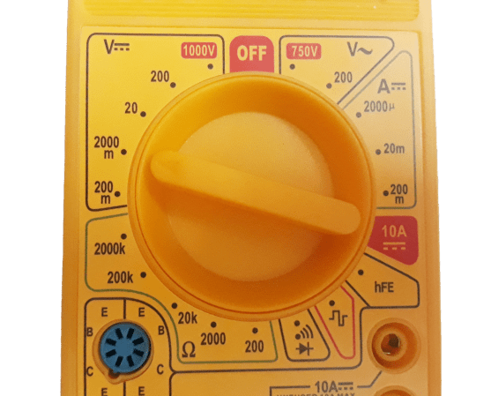

Some of the other parts include:

1. Probes: A DMM has two probes — one red and one black. Each has a plug and a metal strip used to connect your DMM to the electronic components you are measuring.
2. Dial: The dial is used to select the measuring entity. These entities vary based on the type of DMM used.
3. Display: The display shows a digital reading of the measuring entity and displays negative (-) sign.
4. Slots: The slots are used to connect two probes (different multimeters have a different slot configuration for the RED probe):

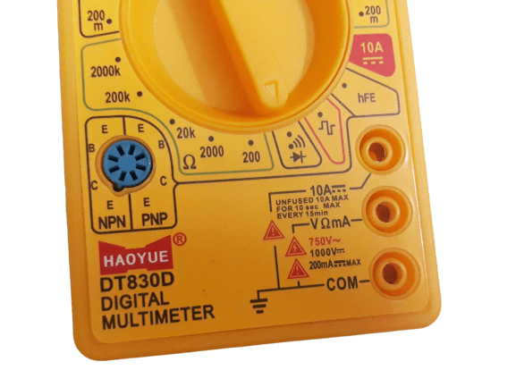

The COM slot is just a common or ground port where the black probe is always connected.

The red probe connects to the VΩmA slot only when you are measuring voltage, resistance, current (less than 200mA), capacitance, continuity, or diodes.

The 10A slot is used when you want to measure currents higher than 200mA. Checking other entities using this slot won't harm the DMM but will give incorrect results

**How to Measure Voltage**

1. Power off the circuity/wiring under test if there is a danger of shorting out closely spaced adjacent wires, terminals or other points which have differing voltages.
2. Plug the black ground probe lead into the COM socket on the meter (see photo below).
3. Plug the red positive probe lead into the socket marked V (usually also marked with the Greek letter "omega" Ω and possibly a diode symbol).
4. If the meter has a manual range selection dial, turn this to select AC or DC volts and pick a range to give the required accuracy. So for instance measuring 12 volts on the 20 volt range will give more decimal places than on the 200 volt range.  
   If the meter is autoranging, turn the dial to the 'V' setting with the symbol for AC or DC (see "What Do the Symbols on the Range Dial Mean?" below).
5. A multimeter must be connected in parallel in a circuit (see diagram below) in order to measure voltage. So this means the two test probes should be connected in parallel with the voltage source, load or any other two points across which voltage needs to be measured.
6. Touch the black probe against the first point of the circuitry/wiring.
7. Power up the equipment.
8. Touch the other red probe against the second point of test. Ensure you don't bridge the gap between the point being tested and adjacent wiring, terminals or tracks on a PCB.
9. Take the reading on the LCD display.

Reading = ________________

**How to Measure Current**

1. Turn off the power in the circuit being measured.
2. Connect the probe leads as shown in the photo below. Plug the black ground probe lead into the COM socket.
3. Plug the red positive probe lead either into the mA socket or the high current socket which is usually marked 10A (some meters have a 20 A socket instead of 10A). The mA socket is often marked with the maximum current and if you estimate that the current will be greater than this value, you must use the 10 A socket, otherwise you will end up blowing a fuse in the meter. On some meters, there is no additional socket for measuring current and the same socket is used as for measuring voltage (usually marked VΩmA).
4. A multimeter must be inserted in series in a circuit in order to measure current. See the diagram below.
5. Turn the dial on the meter to the highest current range (or the 10A range if the probe is in the 10A socket). If the meter is autoranging, set it to the "A" or mA setting. (See the photo above for an explanation of symbols used).
6. Turn on the power.
7. If the range is too high, you can switch to a lower range to get a more accurate reading.
8. Remember to return the positive probe to the V socket when finished measuring current. The meter is practically a short circuit when the lead is in the mA or 10 A socket. If you forget and connect the meter to a voltage source when the lead is in this position, you may end up blowing a fuse at best or blowing up the meter at worst! (On some meters the 10A range is un-fused).

Reading = ________________

**How to Measure Resistance**

1. If the component is on a circuit board or in an appliance, turn off the power
2. Disconnect one end of the component if it's in a circuit. This may involve pulling off spade leads or desoldering. This is important as there may be other resistors or other components having resistance, in parallel with the component being measured.
3. Connect the probes as shown in the photo below.
4. Turn the dial to the lowest Ohm or Ω range. This is likely to be the 200 ohm range or similar.
5. Place a probe tip at each end of the component being measured.
6. If the display indicates "1", this means that resistance is greater than can be displayed on the range setting you have selected, so you must turn the dial to the next highest range. Repeat this until a value is displayed on the LCD.

Reading = ________________

Result :

The voltage, current and resistance for the given circuit was successfully measured.